Verification of Kirchhoff Current Law (KCL) using PSPICE

LAB # 5



Spring 2022

CIRCUIT AND SYSTEMS 1 LAB

Submitted by: MUHAMMAD SADEEQ

Registration No.: 21PWCSE2028

Section: C

"On my honor, as student of University of Engineering and Technology, I have neither given nor received unauthorized assistance on this academic work.'

Submitted to:

Engr. Faiz Ullah

(May 19, 2022)

Department of Computer Systems Engineering University of Engineering and Technology, Peshawar

**Experiment # 5**

Verification of Kirchhoff Current Law (KCL) using PSPICE

**Objectives:**

To verify Kirchhoff’s Current Law (KCL) using electrical simulation tool PSPICE

**Kirchhoff's current law (KCL):**

At any node (junction) in an electrical circuit, the sum of currents flowing into that node is equal to the sum of currents flowing out of that node or the algebraic sum of currents in a network of conductors meeting at a point is zero.

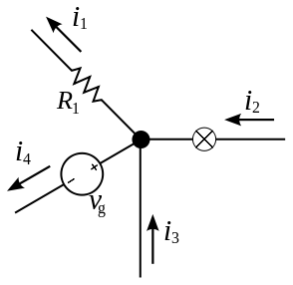

Figure 11 KCL i.e.

**PSPICE:**

Pspice is a circuit analysis tool that allows the user to simulate a circuit and extract key voltages and currents. Information is entered into PSPICE via one of two methods; they are a typed 'Net List' or by designing a visual a schematic which is transformed into a netlist.

**Experiment:**

To verify Kirchhoff's current law (KCL) using PSpice.

**Procedure:**

1. Open schematic program of PSpice
2. Click on the “Get New Part” button on the toolbar
3. Type ‘r’ in the search bar and place three the resistors on the white sheet
4. Type ‘vdc’ in the search bar and place it on the white sheet
5. Type ‘gnd-earth’ and place on the white sheet
6. Now arrange these components on the white sheet according to the circuit diagram as following:

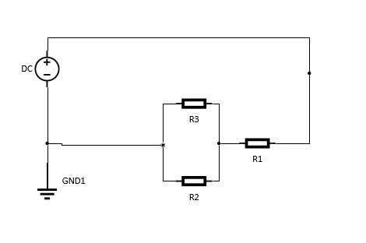

Figure 12 KCL circuit

1. Click on the simulation button in the toolbar and also make sure that the voltage and current biase buttons are pressed so that you can take readings of the circuit

**Observation (Case 1: Same resistors):**

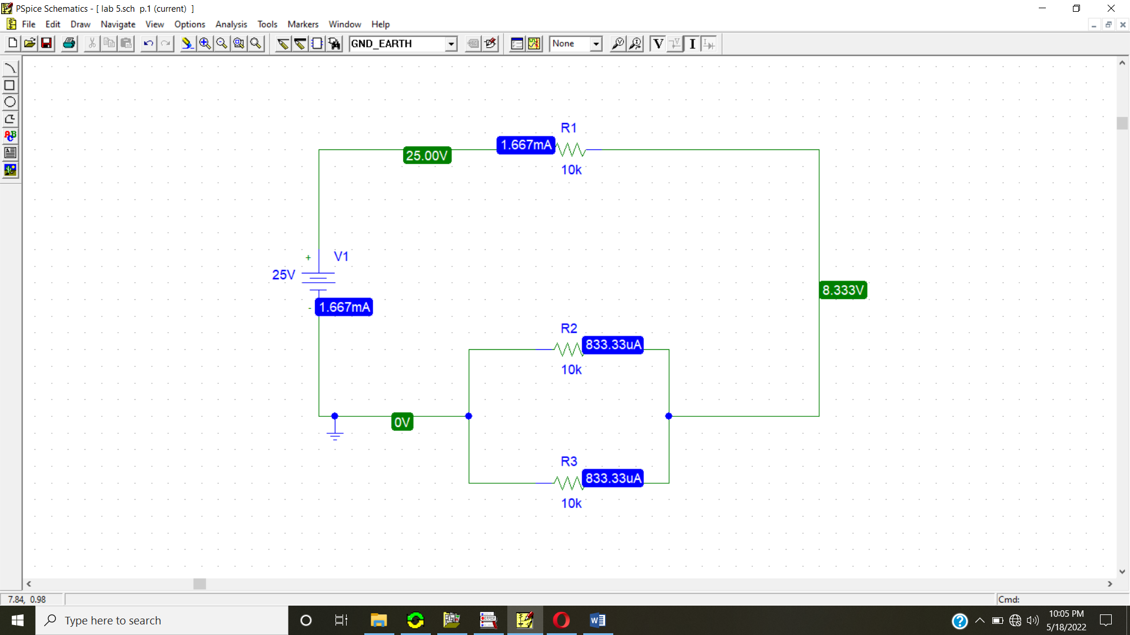

|  |  |  |  |  |
| --- | --- | --- | --- | --- |
| **S.no.** | **Voltage** | **Resistors** | **Currents** | **Node** |
| **1** | **5V** | **10kΩ** | **166.67µA** | **I=I2+I3** |
| **2** | **10V** | **10kΩ** | **333.33µA** | **I=I2+I3** |
| **3** | **15V** | **10kΩ** | **500µA** | **I=I2+I3** |
| **4** | **20V** | **10kΩ** | **666.67µA** | **I=I2+I3** |
| **5** | **25V** | **10kΩ** | **833.33µA** | **I=I2+I3** |

**Observation (Case 2: Different resistors):**

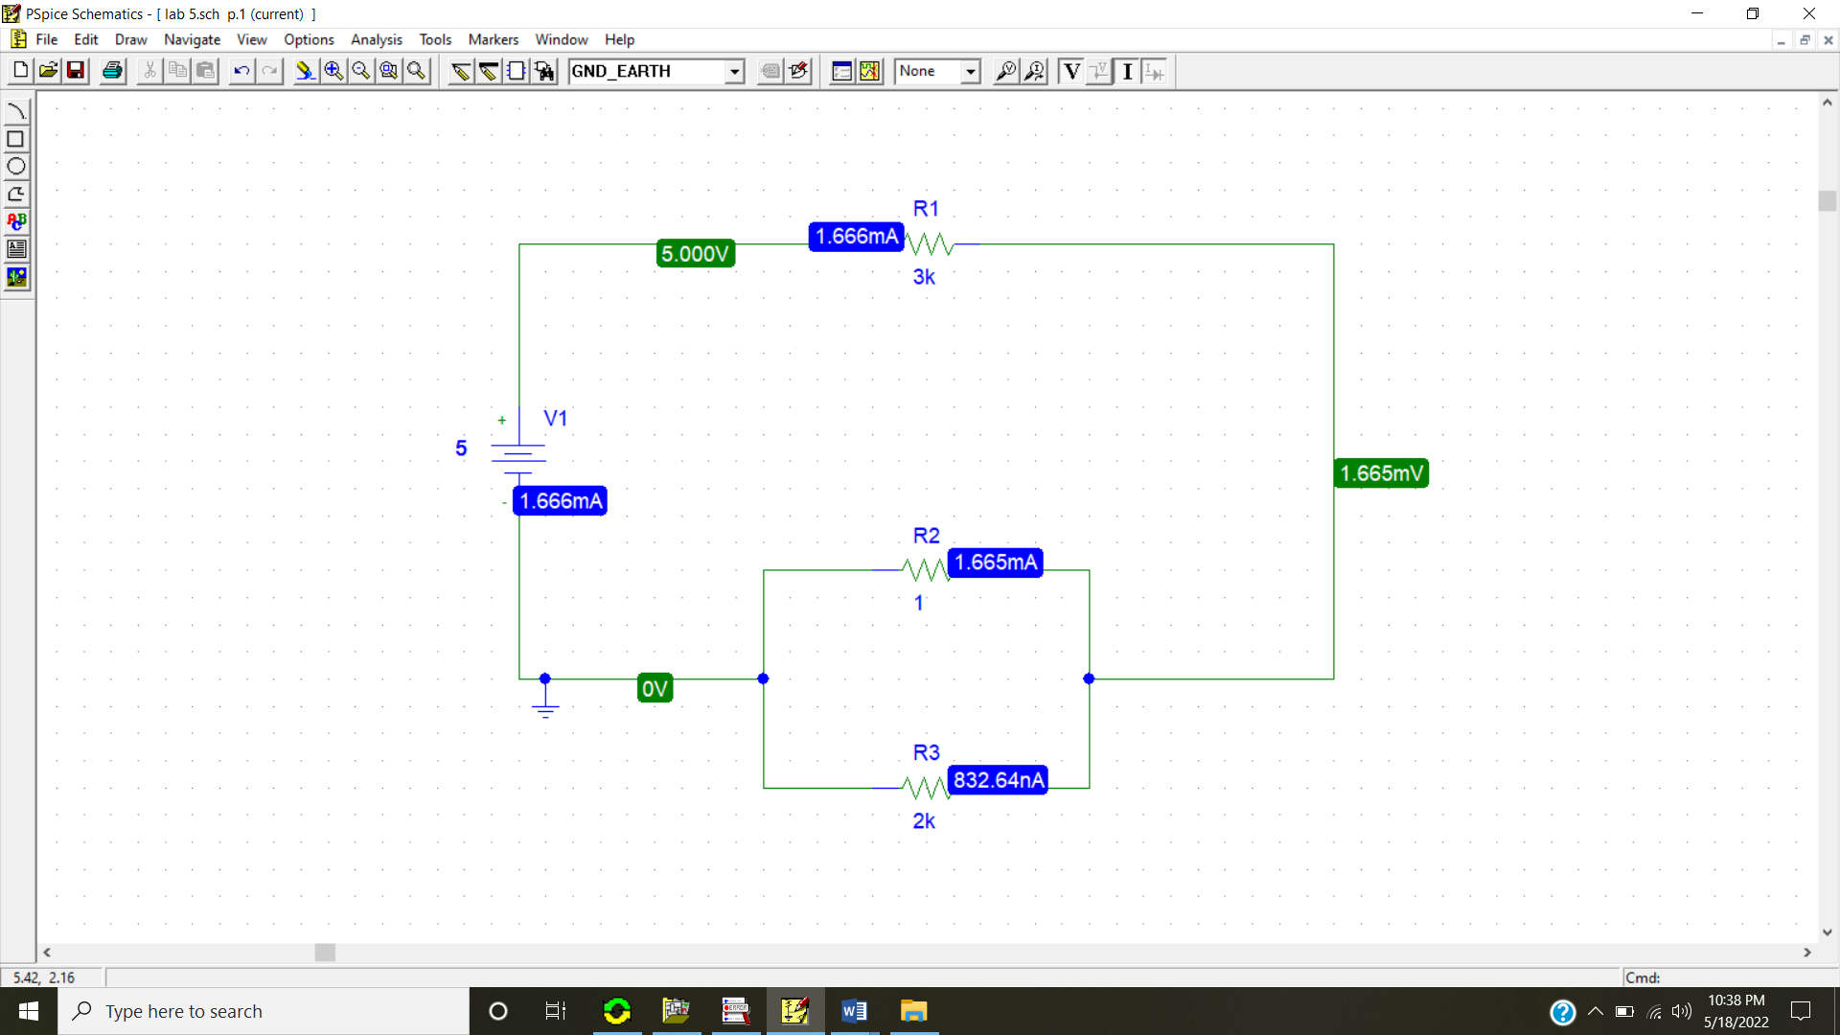

|  |  |  |  |  |
| --- | --- | --- | --- | --- |
| **S.no.** | **Voltage** | **Resistors** | **Currents** | **Node** |
| **1** | **5V** | **1k,2k,3k** | **1.665mA,83264nA** | **I=I2+I3** |
| **2** | **10V** | **1k,2k,3k** | **3.331mA,1.665µA** | **I=I2+I3** |
| **3** | **15V** | **1k,2k,3k** | **4.996mA,2.498µA** | **I=I2+I3** |
| **4** | **20V** | **1k,2k,3k** | **6.661mA,3.331µA** | **I=I2+I3** |
| **5** | **25V** | **1k,2k,3k** | **8.326mA,4.163µA** | **I=I2+I3** |

**Analysis:**

Kirchhoff's Current Law, often shortened to KCL, states that “The algebraic sum of all currents entering and exiting a node must equal zero.” This law is used to describe how a charge enters and leaves a wire junction point or node on a wire.